Improving Manners and Courtesy at Murray High
Submitted by:
Sarah Lewis, Grant Robins, Makayla Stowell, Haley Thornton, Megan Walker
Salt Lake Community College
Murray High School Concurrent Enrollment
COMM 1010
June 1, 2011

Executive Summary and Project Description
At the beginning of the semester, Mr. Saxton asked us what we, as students would like to see improved in the school. We each responded with similar answers, which included crowded hallways, littering in and outside of the school along with vandalism in the parking lot. While discussing the things at Murray High School that the students would like to fix, we used the first step in the Dewey’s problem solving process which was “defining the problem”.
Next, we had to analyze the problem, “at this stage, the group tries to discover the causes and extent of the problem; by doing research” (Adler & Elmhorst p. 249). In analyzing the problem, we each wrote our own anecdotal stories about how the problems at MHS affect each of us as individuals. We concluded that the causes are from careless behavior of the students at Murray High School. After this, we came up with a list of people that the problems at MHS might also affect; the stakeholders. Then, we each gathered the necessary data that we needed for our project by individually interviewing five of the stakeholders as well as obtaining additional data by comparing our high school to another high school (Taylorsville High School).
In order to choose a solution to solve the problem(s) at Murray High School, we spent some time “identifying the characteristics of a good solution” (Adler & Elmhorst pg. 249). We established a strict grading system to make a choice later on in the process. Then we considered possible solutions which included brainstorming without any bias or personal judgment. Brainstorming was the next step in Dewey’s process that we incorporated in our project. We came up with eight possible solutions, after combining solutions that related to each other.
Deciding on a solution was an easy process. We put together a table with the solutions to rate them on a scale of 1-5 to determine how effective they were regarding the previous criteria we had set. By comparing all of the solutions against each other, we were able to narrow down three possible solutions.
These were:
- Using the Student Body Officers to remind the students to be courteous to each other and their school.
- Implementing a media campaign to display a positive message to the school to encourage courteous behavior and reduce littering and vandalism.
- Using announcements by one of the school secretaries to encourage students to go to class on time, therefore reducing the crowding hallways and to pick up their trash.

The next step was to implement the solution, “inventing the solution isn’t enough; the group has to put the plan into action” (Alder & Elmhorst p.250). We decided that we would ask the Student Body Officers to guide the students to go to class and not crowd the hallways. We also decided to separate into two groups; one was in charge of the media campaign and the other was in charge of the announcement campaign. As part of the media campaign, we made flyers that we taped on the lunchroom tables with a catchy saying (having to do with the students throwing away their own trash), posters that we hung up in the stairwells which had catchy slogans about not littering and being polite in the hallways (they also contained pictures of the trash that we recorded in the lunchroom/commons as evidence) as well as asking Spartan Vision to display a video that we made about the trash problem at our school during the morning announcements.

And finally, our last step was to follow up on our solutions. “Even the best ideas don’t always work out perfectly…the group should always check up on the implementation of the solution to see whether any adjustments are needed” (Adler & Elmhorst p. 250). After a month of implementation, we decided to wait a few weeks and to see how our project had impacted our school. After first lunch, we went out into the commons where lunch is typically held and noticed that there were still many flyers on tables and that there was a significant difference in trash that was left on the tables and floors; we had also agreed that we noticed the halls had become less crowded than they were at the beginning of school.

Define the problem
Since COMM 1010 was such a small class this semester, Mr. Saxton decided we would approach the small group problem solving project as a semester long class project and study the concepts of communication through this lens. In group problem solving, it is important to take a systematic approach in order to come up with the best solution possible (Adler & Elmhorst p. 248). John Dewey developed a widely used systematic approach to solving problems which he called the “reflective-thinking sequence”. This is one of the most important concepts taught in COMM 1010, and this is the approach we used in this class.
We began by defining the problem. The first week of the semester we identified an issue we wanted to study as a class and for which we wanted to create a solution. We brainstormed issues around Murray High School that we all wish we could see changed. Some of the things we discussed were: crowded hallways, vandalism in the school and the parking lot, and litter in the hallways, the commons, and the parking lot. Instead of choosing just one of these issues around which to focus our project, we decided they were all part of a general pattern of discourteous behavior and negative climate. Vandalism, trash, and crowded hallways all contribute to the physical environment of Murray High. Since physical environment sends a nonverbal message to people (Adler & Elmhorst p. 111), and since negative messages can create a negative communication climate (Adler & Elmhorst p. 127), we decided that this would be a great project through which to study communication. Therefore, we combined them and created a goal for our project.
Goal of our project: To improve the courtesy and good manners among the student body at MHS

In order to focus our research and thinking, we then stated this problem as an open ended question:
“How can we improve the courtesy and manners among the students at MHS?”

Analyzing the problem
The second step in the reflective thinking sequence is to study the problem thoroughly (Adler & Elmhorst p. 249). It is important to look at a problem from many different perspectives in order to make sure you fully understand it. In this case, we looked at the nature of the problem, the stakeholders involved, the policies and politics regarding this problem, the history of the problem, and the resources available to us to solve the problem. Our research is outlined below:
Nature of the problem - Litter
Garbage is one of the main problems that our class has observed. It is an issue that has a major impact on our school image. This not only involves the quality of the learning environment, but also the teaching staff and all others involved with taking care of the school. Students have displayed discourteous acts of behavior all over the school campus; garbage has been found in the back of pickup trucks and also on windshields. The parking lot is often treated as a big dumping ground for students’ lunch sacks from the nearest fast food place.
Classrooms have proven to be another problem area in the school. Often times there are food wrappers and ripped up paper left under desks that have been carelessly dropped on the floor. Another nuisance students have to deal with is when other students stick their used gum on the bottom of desks. This gets stuck on clothing and anything else that comes into contact with it, not including the fact that it is extremely gross to discover.
The lunchroom/commons area is the most used place in the entire school. It is also the most affected area when it comes to litter. Janitors work many hours a day to clean up after the lunches and to keep this area up to Murray High’s standards. During the lunch hour they also walk around to pick up garbage from tables to make the cleanup a little easier. Students should know to bus their own tables and to take care of their own trash. If students at Murray High would put in a little more effort to clean up their trash, it would greatly reflect on our school image.
We conducted a study in which we gathered the following data: on a regular day during lunch, when the custodians normally roll around a garbage can for students to throw trash into, we counted 5 items left on tables and 14 items left on the floor around the tables. On a day when the custodians agreed to not roll a garbage can around during lunch, we counted 21 items left on tables and 22 items left on the floor. We also documented the trash around Murray High with photos, some of which can be seen in appendix #2 at the end of this report.
Vandalism
We have observed many examples of vandalism at Murray High School. One example is Megan Walker’s car antenna being stolen and broken several times. Another example is Haley Thornton’s truck having garbage dumped in the back of it. According to the M Book (our school’s student handbook) this is vandalism. We have also observed some student’s cars having been squirted with ketchup and mustard. Another place we observed vandalism was in classrooms. We took several pictures of vandalism in class rooms. The most obvious example of vandalism was in the art room. There were carvings on the desk in many classrooms. We collected around 60 or so pictures of examples of vandalism, some of which can be seen in appendix #2 of this report.
Crowded Hallways
Murray High School is a wonderful institution for students to be able to receive an outstanding education. Students are able to become effective communicators, responsible citizens and successful problem solvers due to the teachings in classrooms. Although the students receive every chance of a solid education, there is an obstacle that students must face that interferes with their learning as they travel to and from class - the crowded hallways. Students have a hard time getting to and from class due to the problematic congestion in the hallway on the second floor in the Northeast intersection. Large groups of students often arrive at this intersection and begin talking to each other due to the fact that they don’t want to arrive to their class too early. This causes problems for other students who are trying to arrive at their next class on time. The following includes quotes from current students at MHS who also experience this problem.
“I constantly have to dodge people in the hallway because I don’t want to get run into and it doesn’t seem like the other people are going to move out of the way” says an MHS senior who was forced to weave in and out of people to get to class. “On the second floor, I tripped over somebody's foot because I was trying to get through the intersection and I had to squeeze through the crowds of people surrounding me” says a MHS junior that was affected by this problem. “There were so many people that even with pushing and being polite, I still could not move much…in order to get to class I had to be just as rude as them and I started to just shove people aside so that I could get by…I don’t like to be rude but it really is the only way to get through this hallway” says a MHS senior. “I decided to walk my friend to the staircase that faces 53rd south…by the time I walked down the crowded hall to the staircase and turned around to go back to my class I was nearly late to T.E.A.M. and I walked in right as the minute bell rang” says a MHS junior. Instead of focusing on the tasks at hand in the classrooms, students are preoccupied planning on how they are going to be able to get to their next class on time. “The solution to our predicament was to link arms and try to make our way through the angry crowd in one piece” says a MHS senior.
The overcrowded hallways create an uncomfortable learning environment for students, which makes it harder for them to concentrate in the classroom. This is a physical and mental barrier that students encounter on a daily basis; with these rude behaviors, students are learning that the only way they can go somewhere is to disregard everyone but themselves. This creates a barrier that does not allow students to become effective communicators, responsible citizens and successful problem solvers.

Stakeholders
There are many individuals and groups who are affected by this problem. It is important to look at the problem from all of their perspectives (Adler & Elmhorst p. 248). As a class we brainstormed a list of all of the stakeholders and interviewed some of them to get their perspective on the problem.
Custodians– Megan Walker interviewed our head custodian, Trent Asay; it seemed like he didn’t think some of the things we have talked about were much of a problem. He said that he does notice the crowded halls and vandalism but that they aren’t big problems. However, he did say that litter is a problem because of laziness and lack of professionalism. He said that the litter is mostly in the parking lot and the grounds. Megan asked him how he thinks we can fix this issue, and he said the first step is bringing it to everyone’s attention. The final question asked was what he thinks of the overall manners and courtesy at Murray High; he thinks they are great.
School police officer – Mr. Saxton interviewed our school officer, Russ Burnside: The school officer is affected mostly by the acts of vandalism. He prosecutes anyone who vandalizes according to the laws that are outlined for disruption of school operations. Officer Burnside’s perspective made it seem like there was less vandalism than we had originally perceived. He said there are “less than twelve incidents a year.” He keeps a log of these incidents in his office. It is difficult for people to get away with vandalism at Murray High because there are dozens of cameras all over the school and the video taken from these cameras is saved for 2-4 weeks at a time.
Current students – Haley Thornton interviewed current student Nicole Farnsworth. Nicole shared many of our same feelings when it came to littering. She mentioned seeing litter in the parking lot, the lunchroom, the classrooms, and the stairs. She believed that it reflects a trashy view on the school and that it shows that the students don’t have any respect for their environment. She also commented on how other students see people leaving garbage and that it makes it okay for them to do it. The students don’t respect the school or the janitors and it isn’t their duty to pick up after them when they are feeling lazy. Visitors view this and notice more than the students might. She felt that as a society, we are failing by not teaching this more and making sure kids have respect.
She didn’t see vandalism as a huge issue at Murray but she does see it occasionally, especially in the restrooms. She views it as unnecessary and sad, and thinks that we should be above that. Nicole sees the crowded hallways as a big problem at Murray. She again had many of the same views that we did as a class, commenting on the North East corner. She spoke of a time that she was trying to get through with her art portfolio, which is pretty big, and how people just crowded into the corner and no one could get through. Her portfolio was getting hit and kicked by people trying to get through. She also believed the worse time it is crowded is between the first and third period of the day.
Nicole thinks that if manners and basic courtesies at Murray were improved it would benefit these issues and make them better. However, there will always be those students that won’t change and would ruin it for everyone else. She also believes that parents should make manners and respect a priority and not make the schools do it.

Administration – Grant Robins interviewed our assistant principal Debbie Sorenson. There was a lot to be learned regarding littering and student behavior in Murray High. We spent quite a bit of time talking about janitors and their efforts for perfection. There are two crews, each with a specific purpose and with duties relating to this objective. They do everything from keeping the air clean, to sanitizing the school bleachers. She talked very highly of their duties and responsibilities in Murray High.

Teachers – Teachers are affected by this because this is their workplace and they have to spend most of their time here during the school year. The most direct way they are affected is in how students take care of their classrooms. We collected evidence of both trash and vandalism in different classrooms. Some of these photos can be viewed in appendix #2 at the end of this report. We have also shared anecdotes about times when teachers have asked students to clean up and students have refused.
Future Students - Makayla Stowell interviewed future Murray High student Taylor Winsness. Taylor informed Makayla that she thinks that Murray is a pretty clean school. She had no complaints about litter or vandalism that she has seen in the hallways or on school grounds. She seemed to be rather impressed with Murray High School and its students.
She also thinks that the students at Murray are nice and polite. She said that she had never seen or heard any evidence to the contrary in her many visits to Murray High School. No one has ever made her feel unwelcomed when she has visited the school. She also didn’t feel any hostile feelings from the students, even though she is only a freshman.
She is very excited to go to Murray next year because she thinks it is a nice school. In her opinion, it is one of the best schools in the region. Her older sister is on the high school volleyball team so she has traveled to many other schools in the region to see her sister’s games. She said that Murray and Cottonwood are about the same in regards to politeness and cleanliness. She said that Murray is considerably nicer than Granger. She would most like to go to Murray over those other schools.
Community- Our school is used by the community and visited by members of the community several times per year. The Murray School District Community Education Liaison Joan Shuman rents our facility to the Murray Community Dance Company, The Murray Symphony, The Murray Community Choir, the Murray Arts Council, and the Murray Arts in the Park, just to name a few. They use our building to rehearse, perform, and conduct other events as needed. The cleanliness of our building has a dramatic affect on how people perceive us. Physical environment sends a nonverbal message to the people who encounter it (Adler & Elmhorst p. 111).
Parents – Parents have a choice to send their children to Murray High School or not. According to our principal Mr. Bushnell, about a third of our student body comes to Murray from outside the district. We depend on those students to maintain our classification as a 4A school. If we have a school where students don’t feel safe or where students don’t feel comfortable in their surroundings, they may choose to go elsewhere. MHS is an organization and the culture of an organization can affect whether people want to be a part of that organization (Adler & Elmhorst p. 59).
School Day care (Spartan Station) - Sarah Lewis interviewed the manager of Spartan Station, Sarah Buck: Ms. Buck explained that the kids love getting breakfast in the mornings. However both the kids and the teacher have a very hard time while they travel through the crowds of students in the commons to get breakfast. Sometimes the teachers have to instruct the kids to move to one side of the hall, cling to the teacher and cart; sometimes the kids aren’t able to go get breakfast due to this hassle. The day care even had to make a new “head count” rule before and after field trips due to the fact that a child was lost in among the crowds of students in the hallways. Ms. Buck also expressed that the students of MHS are huge examples for the kids. The day care allows students to help out during many class periods and she has found that the way they dress, talk and act have a huge affect on the kids due to the fact that if the kids see that a “big kid” is acting a certain way, then its okay for them to do the same.
The kids are taught concepts of responsibility at the day care which includes the concept of pride; to have pride in certain areas they play in and not throw/leave their garbage on the floor, but if they leave their garbage in that place, they need to be responsible and throw it away. For example, if the kids don’t pick up after themselves, the toys they were playing with are taken away until they are cleaned up and if they leave their wrappers outside, they don’t get snack any more that day. Ms. Buck was also asked what type of message would be sent to the kids if they noticed several pieces of trash lying on the ground inside or outside of the school. She replied that it would seem that the students of the school just don’t care about their school or community due to their actions and attitudes. Community is a top priority that is being taught to the kids and to witness this type of attitude from the “big kids” would be confusing to them.
Ms. Buck explained how important it was how to teach the kids the differences between right and wrong. The kids don’t really have problems with vandalism, however if one of the kids were to color on the walls or tables, they would need to help scrub it off and depending on the coloring implement that was used then it wouldn’t be able to come off which shows them that sometimes things can’t be fixed and they need to think about how things can hurt their community and how they are taught to love their community. She suggested that the school was great, however she would like to see the students watch their language better in the hallways (if kids hear vulgar words, they have to be explained that sometimes adult words are hurtful and shouldn’t be used by the kids). Also, she would like to see the programs in the school become more involved with the kids (more kid-friendly) so the kids could explore the different types of activities in the school and become more involved in their community.

Policies & Politics
While discussing the problem of overall discourtesy of MHS, we talked about the policies and politics that influence how this will be resolved. The policies we discussed are all found in the M Handbook and the politics were things that we came up with on our own.
The policies we decided the problem of overall discourtesy fits into the most are disruptive acts and pranks prohibited, safe and orderly schools, and vandalism is prohibited. All of the issues we have discussed, littering, vandalism, crowding the hallways, etc., fit into the category of disruptive acts (M Book p. 23).
Within the safe and orderly schools policy, we put each issue into a specific category. We decided that littering and not cleaning up when asked goes under willful disobedience. The students have been asked to not litter and to clean up after themselves, yet they don’t listen and choose to litter and leave their messes for others. Vandalism is under the category of willful destruction or defacing of school property because that is exactly what vandalism is. Lastly, we think the crowding of hallways goes under behavior that threatens the operation of the school because it can cause students to be late to class. In the M book, the consequence listed for each of these policies is suspension.
The politics we came up with are lack of resources, students protecting each other, worthless battles, and some students just don’t care. What we mean by lack of resources is the fact that we, or the school administration and officers, can’t be in all places at all times and things are going to happen that can’t be stopped. The politics of students protecting each other is just that: nobody wants to be a tattle tale or snitch because then they won’t be “popular.” There are some battles that just aren’t worth the fight. There are over 1500 students at Murray and it is impossible to control the behavior of all of the students. Therefore, some of the smaller battles are ignored because bigger issues need to be resolved first. Some students just don’t care about the situations we as a class have determined to be problems. Some students don’t think litter and vandalism are problems, and they don’t think stopping in the halls and crowding them is discourteous, let alone a problem at Murray High.
History
Surely MHS is not the first school to deal with this issue, so we decided to study other schools to identify how they have approached this problem. Therefore, we took a trip to Taylorsville High School. When we visited Taylorsville High School we were able to meet with two of their trackers, one being an academic tracker and the other a full time tracker, and also the head janitor. While we were there we asked them how they have dealt with littering, vandalism, and discourteous behaviors with the students such as crowded hallways. For all of these problems their solution seemed to be what they call trackers. Taylorsville has five of these trackers, three academic and two full time trackers that patrol the school grounds.
When it came to littering, no one we talked to seemed to think of it as a big issue. The only area they saw that could be improved upon was the hallways but even the hallways were considered really good compared to previous years. In their lunchroom they have large signs telling them that they need to bus their own table and, according to the janitor, those have helped with trash in the lunchroom. To prevent littering in the parking lot, the two full time trackers spend approximately two hours out patrolling the parking lots. When we brought up vandalism at the school no one seemed to think of it as a problem saying that this year especially had been very good when it came to vandalism.
To help with discourteous behavior and the crowding of hallways in-between classes the school has the five trackers and one college counselor stand in the hallways to make sure that the students got to class and didn’t linger. They have three trackers on the second floor and the other two plus the counselor on the main floor. Two minutes after the final bell rings they start giving out truancy tickets, which can range from three to five dollars. Giving out tickets seems to be an effective way to help reduce these problems.
When it comes to solving these issues, Taylorsville seems to rely heavily on their trackers. It also helps that these trackers have the power to write tickets. Some others ways they have used to help these problems were to recruit the help of their SBO’s and to also have public service announcements on channel one.
Resources available
We identified the following as things available to us at MHS to help us solve this problem:
- SVTV – our weekly broadcast of announcements. Allows us to send a message to almost everyone in the school
- Announcements (Judy) – our office secretary. She is “famous” for her announcements because they are humorous and distinctive
- Posters/signs
- Officer Burnside
- Administration
- Communication textbook
- Service day (in April)
- The M Book

Criteria
Now that we have thoroughly studied the problem, we must decide what a good solution looks like. This is called criteria and it must be established before we actually start creating solutions (Adler & Elmhorst p. 249). Based on our knowledge of the problem, we made a list of nine criteria that any solution must meet in order to be effective:
A good solution will…
  - Use existing resources within the school.
  - Not require new expenses or spending from ourselves or the school.
  - Elicit a positive response from the Janitors regarding any improvement in cleanliness of school.
  - Reduce the number of reported incidents in vandalism.
  - Show a decrease in congestion according to video evidence.
  - Elicit an increased awareness among students of their responsibility as citizens of MHS.
  - Increase the sense of community with the Spartan station daycare.
  - Decrease the actual number of trash counted in the commons and our overall impression of trash in the parking lot.
  - Be easily implemented by the people in this class.

Consider possible solutions to the problem
Once we established adequate criteria against which our solutions can be judged, the next step was to consider possible solutions to the problem (Adler & Elmhorst p. 250). Many groups jump to this part of the process early on, but it is important to work through the problem systematically before you start coming up with solutions. As a class, we brainstormed a long list of ideas. Our brainstorming process focused on creativity, quantity of ideas over quality, and being open to all spoken ideas and withholding judgment during the brainstorming phase (Adler & Elmhorst p. 250).
Brainstorming list
- Signs on tables
- Signs on walls
- Paint parking lot
  - Pink
  - Don’t litter here
- Sidewalk chalk
- PSA’s on SVTV
- Judy announcements
  - Games and contests – prizes to pick up trash
    - 3 before 3:00
- Posters and signs
- Skit
- Littering fines/suspensions
- Tougher policy/stricter enforcement
- Have Judy (or someone) sing “clean up, clean up..”
  - Over PA or with a bullhorn
- Trackers like Taylorsville
  - More hall monitors
    - Especially on the second floor
- Cheerleaders cheer to get people to go to class
- Assemblies
- Announcements in T.E.A.M. class
- More garbage cans
  - In commons and parking lot
- Newspaper stories
- Newsletter announcements
- Student hall monitors
- SBO’s involved in monitoring and enforcing
- Region contest for cleanliness of facilities
- Party for reaching cleanliness goal
- Political cartoons
- Fliers on cars
- Outside media
- Big Buddha
- Facebook pages/ads
- School website
- District website

Decide on a solution
The next step in our process was to choose a final solution (Adler & Elmhorst p. 250). This is done by evaluating our solutions against our criteria to see which one meets the criteria best. Before we did this, we narrowed our list down to a more manageable size. It was clear some of the ideas wouldn’t work at all (a region contest that involved other schools, having a big party, getting the cheerleaders to cheer between classes, hiring people to track students), so we threw them out immediately. Others we combined into comprehensive ideas to create what we viewed as even stronger ideas. Once we finished this, our list was eight items long:
- Use SBO’s
- Create a media campaign (poster, fliers, SVTV, sidewalk chalk, etc.)
- Announcements
- Tougher punishments/rules
- Sending our message out in the school newspaper or school newsletter
- Having contests or games in the school
- Creating an internet campaign (facebook, twitter, district website, school website, etc.)
- Using outside media (Big Buddha, 2News this morning, etc.)

After we created this list, we made a chart that allowed us to score each of these solutions against each of our criteria. We gave each item a score from 0 – 5 based on how well we thought it would meet each criterion:

 | Use existing resources | Not require new expenses | Elicit a positive response from the custodians | Reduce reported incidents of vandalism | Show a decrease in congestion according to video | Increased awareness of responsibility as citizens of MHS | Increase the sense of community with the Spartan station daycare | Decrease the actual amount of trash in commons and parking lot. | Be easily implemented by the people in this class | Total
Use SBO’s | 5 | 5 | 3 | 2 | 4 | 5 | 3 | 4 | 5 | 36
Media campaign | 5 | 5 | 4 | 1 | 3 | 4 | 4 | 4 | 5 | 35
Announcements | 5 | 5 | 4 | 3 | 3 | 4 | 3 | 4 | 5 | 36
Tougher punishments/rules | 5 | 5 | 3 | 4 | 3 | 1 | 0 | 2 | 1 | 24
Newspaper/Newsletter | 5 | 5 | 3 | 2 | 1 | 2 | 1 | 2 | 5 | 26
Contests/games | 2 | 2 | 4 | 1 | 1 | 5 | 3 | 5 | 1 | 24
Internet | 5 | 5 | 2 | 2 | 3 | 4 | 4 | 2 | 3 | 34
Outside media | 0 | 5 | 2 | 1 | 1 | 4 | 1 | 3 | 1 | 18

Rather than choosing the highest scoring solution, as a class we decided that we would combine our top three solutions and implement all of them. Using time in class and careful planning, we decided this was feasible. Our proposed solution was the creation of a multimedia campaign, including TV Public Service Announcements, posters, fliers, and sidewalk chalk, along with a series of announcements in between classes and during lunch in the commons. In addition, we decided we would use the SBO’s as part of this campaign in order to create the perception that it was coming from student leadership. Our next step was to plan out and execute our implementation.
Implement the solution
This is the most critical part of any solution – actually putting it into action (Adler & Elmhorst p. 250). To implement our solutions, we divided the class into two committees. One committee was assigned the task of planning and implementing our media campaign. The other committee was assigned the task of planning and implementing our announcements.

Media campaign
Committee Members – Grant Robins, Megan Walker, and Makayla Stowell
Our posters need to catch attention. They need to be neat and colorful and be in bright colors such as, pink, orange, yellow, blue, etc. We will see what color paper we can get from the library and use those. There will be a total of 8 posters, 4 for littering, and 4 for crowded hallways. We will have two poster of each color mentioned above. We will use our own artistic abilities and computers to make the posters during class in the next week on Tuesday and Thursday the 19th and 21st. When we are finished making the posters, we will put them up in the stairwells on all 3 floors. The posters will be up by next Thursday. The posters will be big enough to catch attention. They will include sayings like, “Do it right, KEEP IT POLITE!”, and “traffic light- green means go, don’t stop to chat.” They will also have pictures of people putting garbage in cans and things like that. We are considering putting some of the pictures that we took on the posters.
Our fliers need to be the same colors as our posters so that people can see they go together. They will have saying like “Remember to clean up” and “Buss your own tables.” We will put them all over the school wherever the administration will allow us. We will especially out them in the lunch room and commons area. We will tape them to the lunch room tables. We will use Microsoft Word on the computer to make our fliers. We will use bright colored paper and black ink. We will do the fliers on Friday the 15th.
Our SVTV commercial will be shown everyday starting as soon as we get it done. We are going to work with Erik Martin from SVTV to make the commercial. He will help us with the SVTV cameras. We want it to be melodramatic and attention getting. We will show some of the pictures that we took and play sad music. It will be 30 seconds long. We will try not to have anyone actually acting in it unless the SVTV people want to because Makayla, Sarah, and Grant are a little shy. Mr. Moffit said that he would air our commercial. We also want the SVTV anchors to say “Don’t forget to take care of your school, Murray!” at the end of the commercials every day. On TEAM days, we will also have SVTV announce to keep walking to team and not stop to chit chat. We will have to see when Erik can work with us to do this. We are thinking the 25th and 27th.
We will create all of the sidewalk chalk ourselves on April 25th. Our drawings will include pictures of trash with a big “x” around it and sayings like “Clean up after yourselves” and “Keep it clean.” Our art will be outside the main doors and outside the choir doors so that everyone that walks in those doors can see it. We will also put some art on the sidewalk outside the doors by the football field on the north side of the building. We are going to bring sidewalk from our own houses.

Announcements
Committee members – Haley Thornton and Megan Walker
The announcements will be about cleaning up trash during lunch and before/after school and about not crowding the hallways. We don’t think we should write out exactly what the announcements will say; we feel like telling Judy exactly what to say will make it less effective because then it won’t be as funny because of her personality. Although, we may not have Judy do all of the announcements; the SBO’s will be doing some. We will give them the general idea of what needs to be said and they will write the script on their own.
We would like the cleaning up announcements to be done after both lunches in the commons. We can’t have them done over the intercom because of the other classes going on, so we were thinking whoever does the announcements can use a microphone or bullhorn. These announcements will say something along the lines of: “Don’t forget to clean up after yourselves. The janitors are not your mother.” We will tell Judy or whoever is giving the announcements that we want them to be about having the students clean up their own trash, and they will decide what to really say. We think these should be done only once a week because more than that might be too much and seem like nagging. So, the day we decided to do this is on every Wednesday. We think this is the best day to do it because it is in the middle of the week and would make it seem more like a reminder than a warning. We would like these announcements to start on April 20th.
The hallway announcements will be done once during the day, in between classes. We think these should be done on every Monday and Thursday. We chose these days because we felt like having it two days in a row would be too much and we wanted it to be on an A and a B day. These announcements will be about keeping it moving in the halls and not crowding the hallway. Again, we will just give whoever says the announcements a general idea and they will come up with their own way to say it. We would like these announcements to start on April 18th.
We talked to Judy on April 11th and she said that she is willing to do the announcements for us, as long as we reminder her when we want her to start doing it. She will be gone for a couple weeks and said she should be back on the 25th. We told her that all she needs to do is say something about cleaning up after ourselves after both lunches and not crowding the hallways. She said that would be fine and that she will do that for us, starting on the 25th.

Follow up on the solution
The final process in the reflective thinking sequence is to evaluate how well the plan has worked and determine what adjustments need to be made (Adler & Elmhorst p. 250). Since this project happened at the end of the year, there won’t be any opportunities to adjust the implementation. Therefore, we will conclude the process with a report on the implementation and a self analysis regarding how effectively we followed through with our plan.
We used many techniques to implement our plan. We decided to use media and announcements as our main ways to get our plan out to the school. With the media, we made posters, signs, a commercial for SVTV, and drew with sidewalk chalk. With the announcements, we had planned on having our secretary, Judy Anderson, make announcements involving litter and not crowding the hallways. However, the announcements didn’t work as planned.
We had two to three people on each campaign. Grant Robbins, Makayla Stowell, and Sarah Lewis were on the media campaign. Megan Walker and Haley Thornton were on the announcements campaign. Grant, Makayla, and Sarah decided all of the details of the media campaign, such as how many posters and signs to make. Megan and Haley decided when the announcements would be made and generally what the announcements would say.
As a group, we put together the signs and posters. The signs said “Be Polite, Do It Right! Clean up after yourself!” and “Be Polite, Do It Right! Bus your own tables!” We printed them on bright colored paper and put them on the lunch tables and around the commons. The posters were put up in the stairwells on the first, second, and third floor. They included sayings like, “Really Murray?, Really??” and “Cars don’t stop in the middle of the road to talk so neither should you.” Another poster said, “Love your school, pick up your trash.”
Unfortunately, the announcements did not work out as planned. Megan and Haley went and talked to Judy Anderson twice, but the idea was not communicated well. The first time they talked to her, they asked her if she would be willing to make announcements about cleaning up and crowding the hallways. She said that she would do that in a few weeks when she got back from vacation. After she got back, Megan and Haley went in to talk to her again and this is where the confusion started. They asked her if she remembered what they had talked about a few weeks previous. Judy told Megan and Haley that they could come in that day after school and make the announcements. We think she thought that they would be doing the announcements and they haven’t been back in to talk to her about it since then.

The media campaign was in charge of making the SVTV commercial. The commercial showed pictures of the dirty school that we took and played the theme from Schlinder’s List, it also had some of the sayings that we put on our posters. We asked the teacher in charge of SVTV to play it for us and he said he’d play it until the end of the year. However, we haven’t seen it broadcasted.

Our implementation was mostly focused on our media campaign because it was the easiest part to follow through on. We were able to implement everything that was planned in the media campaign. Besides the commercial, we didn’t have to rely on anyone but ourselves. When it comes to implanting a plan we learned that it is important to be specific when communicating plans to others and when asking for help.
Conclusion
Our COMM 1010 class set out to solve some real-world problems at Murray High School. To do this, we followed John Dewey’s Reflective Thinking Sequence (Adler & Elmhorst p. 248). We made this a class project and focused all of the concepts and other projects for the semester around this effort. The problem we chose to focus on was improving manners and courtesy at MHS. Specifically, we focused on reducing litter, vandalism, and crowded hallways. Using Dewey’s system, we stated our problem as an open ended question, analyzed our problem, established criteria for a solution, brainstormed possible solutions, chose a solution, implemented the solution, and followed up with critical self analysis. We had limited success but learned a great deal about problem solving, working in groups, communication, and compiling a comprehensive report.

Works Cited
Adler, R., Elmhorst, J. (2010). Communicating at work. New York, NY: McGraw-Hill Companies, Inc.
Murray High School Parent/Student Handbook 2010-2011. Murray UT.
COMM 1010 class notes, Salt Lake Community College, Spring Semester 2011 Will Saxton instructor

Appendix #1
Solution Analysis Chart
 | Use existing resources | Not require new expenses | Elicit a positive response from the custodians | Reduce reported incidents of vandalism | Show a decrease in congestion according to video | Increased awareness of responsibility as citizens of MHS | Increase the sense of community with the Spartan station daycare | Decrease the actual amount of trash in commons and parking lot. | Be easily implemented by the people in this class | Total
Use SBO’s | 5 | 5 | 3 | 2 | 4 | 5 | 3 | 4 | 5 | 36
Media campaign | 5 | 5 | 4 | 1 | 3 | 4 | 4 | 4 | 5 | 35
Announcements | 5 | 5 | 4 | 3 | 3 | 4 | 3 | 4 | 5 | 36
Tougher punishments/rules | 5 | 5 | 3 | 4 | 3 | 1 | 0 | 2 | 1 | 24
Newspaper/Newsletter | 5 | 5 | 3 | 2 | 1 | 2 | 1 | 2 | 5 | 26
Contests/games | 2 | 2 | 4 | 1 | 1 | 5 | 3 | 5 | 1 | 24
Internet | 5 | 5 | 2 | 2 | 3 | 4 | 4 | 2 | 3 | 34
Outside media | 0 | 5 | 2 | 1 | 1 | 4 | 1 | 3 | 1 | 18

Appendix #2
Photo Evidence of Litter & Vandalism
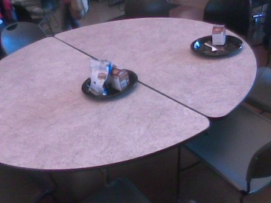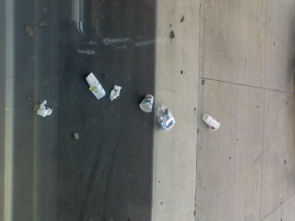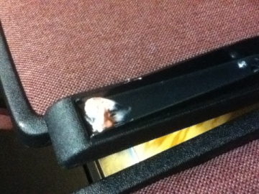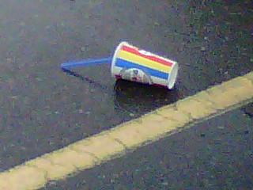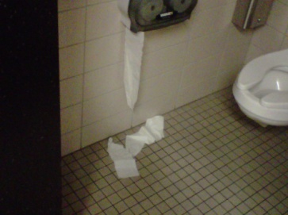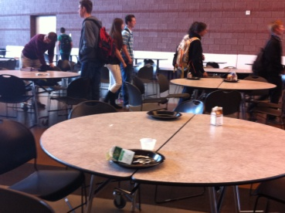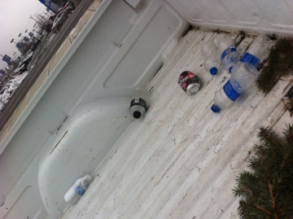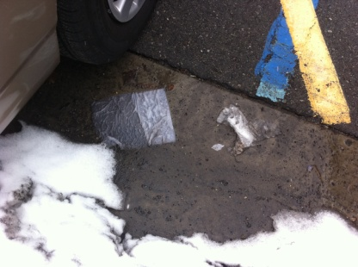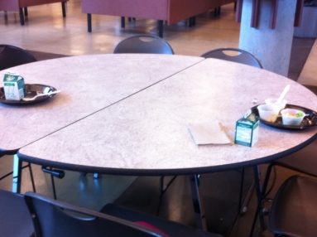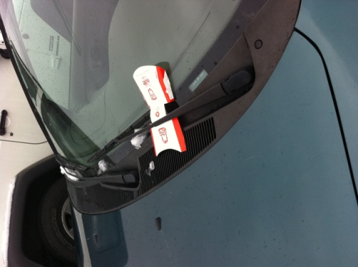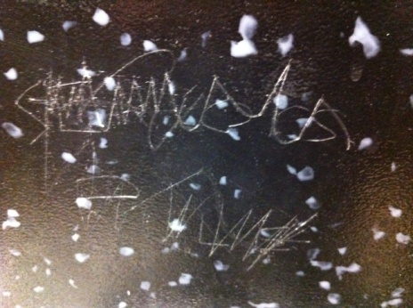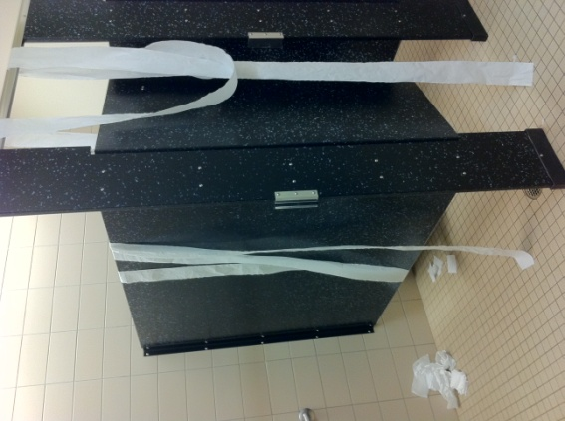

Appendix #3
Posters and Fliers from our media campaign
